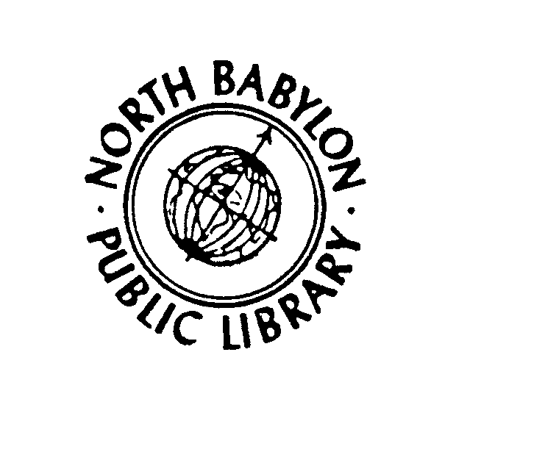
North Babylon Public Library
815 Deer Park Avenue
North Babylon, New York 11703-3812
(631) 669-4020

MUSEUM PASS POLICY
1) Free Museum Passes are available to North Babylon Public Library cardholders in good standing who have signed the Museum Pass User Agreement. A new agreement form must be signed each time a museum pass is checked out.
2) Passes must be reserved in advance and handled by an adult (18 years or older) family member. Only one Museum Pass may be checked out to a patron at a given time.
3) Museum Passes may be borrowed for up to 3 days, and must be returned to the Library no later than 11:00 AM on the due date, i.e. Museum Pass reserved for Sunday, picked up on Saturday after 3:00 PM returned on Monday by 11:00 AM (except Sunday, 2:00 PM). Museum Passes may not be returned in the book drop. Museum Passes are to be handed back to a Reference Librarian to be checked in properly.
4) Reserves will be taken up to 2 months in advance of the desired date. Reservations will be taken either in person or by telephone at 669-4020 at the Reference Desk.
5) In order to ensure that the Museum Pass can be given to the next patron, keep in mind that there is a $40 late fee per day, so please return it promptly.
6) In the event that non-return of a Museum Pass necessitates the Library to pay the
entrance fee for the next user that entry cost to the museum will be
attached to the borrower's record in addition to late fees.
7) In the event of loss or mutilation of a Museum Pass, a fee will be charged for the replacement cost of that Museum Pass.
8) Patrons should call the museum directly for information on hours of
operation, parking and/or directions.
9) The Library staff reserves the right to monitor usage to ensure fair access
for the greatest number of patrons.
10) Museum Passes are available for the following Museums: American Museum of Natural History (http://www.amnh.org/) – 2 adults, 4 children Intrepid Sea, Air and Space Museum (http://www.intrepidmuseum.org/) – 6 any age Brooklyn Botanic Gardens (http://www.bbg.org/) – 2 adults, children under 16 years
Approved by the Board of Trustees
October 20, 2009

North Babylon Public Library
815 Deer Park Avenue
North Babylon, New York 11703-3812
(631) 669-4020

MUSEUM PASS AGREEMENT
- Museum Passes must be reserved in advance and handled by an adult (18 years or older) family member. Reservations are available only for North Babylon Library cardholders in good standing. Only one Museum Pass may be checked out to a patron at a given time. Please pick up the pass at the Adult Reference Desk after 3:00 PM on the day prior to use.
- Please return pass to the Adult Reference Desk by 11:00 AM on the due date (except Sundays, due by 2:00 PM). Other patrons may be waiting to use it. Thank you.
- In order to ensure that the Museum Pass can be given to the next patron, keep in mind that there is a $40 late fee per day, so please return it promptly. In the event that non-return of a Museum Pass necessitates the Library to pay the
entrance fee for the next user that entry cost to the museum will be
attached to the borrower's record in addition to late fees.
- Any user who loses a Museum Pass will be charged the replacement cost of that
Museum Pass.
American Museum of Natural History--$115
Brooklyn Botanic Gardens--$175
Intrepid Sea, Air and Space Museum--$500
- Patrons should check on their own for information on museum hours of
operation, parking and/or directions. Please remember to bring library card for ID at the Museum.
- The Library staff reserves the right to monitor usage to ensure fair access
for the greatest number of patrons.

______________________________ _________________
Signature Date
________________________ _________________
Library Card Number Patron Phone Number
________________________ _________________
Museum Name /Visit Date Librarian’s Initials

