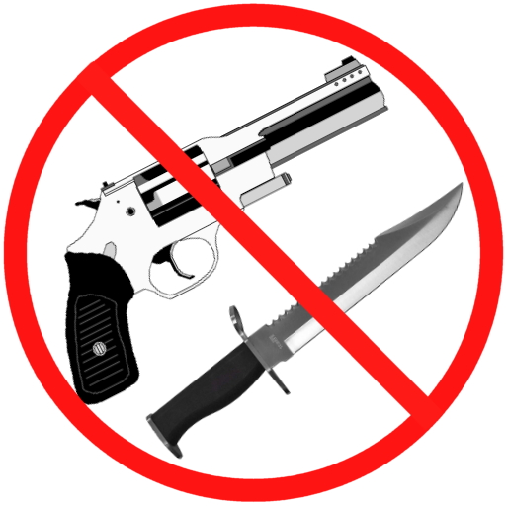

No weapons, guns, knives, etc.

Approved by the Board of Trustees, December 18, 2012

